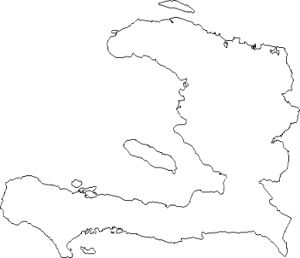
Arleta High School’s
Arleta High School's
First Annual 5k Walk-a-thon
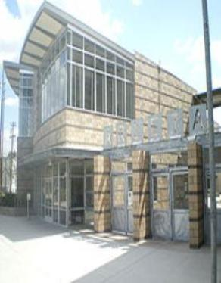
Saturday, April 17, 2010

Arleta High School

Check-in at Beachy Side Gate
14200 Van Nuys Blvd
Change Haiti
Arleta, CA 91331
Walk-a-thon
Check-in at 7:00 a.m.
Walk begins at 8:00 a.m.

--------------------------------------
Change Haiti 5k Walk-a-thon
Entry Form
(Please Print)

*If you would like to receive a Last
commemorative t-shirt, a $10 fee Name_______________________
must be paid by Friday, March 26, 2010
First
Size: __S __M__L__XL __XXL Name_______________________
___Arleta Student ____Other
*Cash Only* Emergency
Contact #_____________________
*For further information, please contact Signature_____________________ Mrs. Villafaña at cvilla4@lausd.net or at
(818) 686-4100

By registering for Arleta High School Change Haiti Walk-a-thon, I acknowledge that participating in the event is a potentially hazardous activity. I will assume any and all risks associated with this event and agree to hold harmless Arleta High School, L.A.U.S.D, corporate sponsors and all others connected with this event. By registering this entry I hereby acknowledge having read this release and waiver, and by accepting a race number accept it’s terms.

